Hypoglycaemia Care Action Trial
Following the successful Hypoglycaemia project in your area, there will be a one month trail of the new Hypoglycaemia care action label.
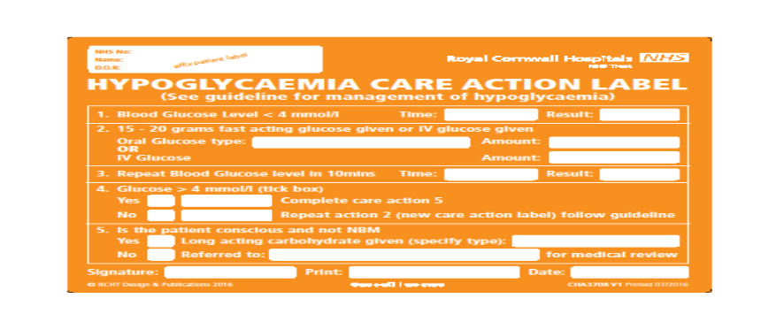
- 
Any BG < 4 mmol/l even without any symptoms is a Hypo and needs to be treated according to the hospital guideline

- When the BG is < 2.5 mmol/l there is glucose deprivation to vital organs and cells. This can cause drowsiness confusion, and if untreated could lead to unconsciousness and Hypoxia and cell death. Prompt and immediate action is needed.

- It is fraudulent to share your bar code for BGM with fellow colleagues. Nurses from Wales have had civil prosecutions upheld for fabricating BG results.
Aim: Raise awareness of correct Hypoglycaemia treatments and improve compliance with the Hypoglycaemia treatment algorithm.
Objective : Improve patient outcomes following Hypoglycaemia.
Trial Expectations
- Any Hypoglycaemia episode (BG < 4mmol/l) is treated according to the Trust Hypoglycaemia guideline.
- The Hypoglycaemia Care Action Label is placed in the Nursing documentation and fully completed for each event.
- Any Hypoglycaemia episode without a Hypoglycaemia Care Action Label in the nursing documentation will need to have an incident form completed.
- Incident forms will be completed by the HCP who identifies the non-compliance.
- DISN`s will review pts. Diabetes management for all Hypoglycaemic episodes that occur and the nursing documentation for compliance Mon – Fri.

